]Q: (Math 1.1) Animal scientists have found that the probability of finding small ears in Cats and Dogs are 0.8 and 0.1, respectively. Suppose An animal is observed with Large Ears.
- What is the probability that the observed animal is a dog?
- To which class the test animal will be classified by the MLE classifier - CAT or DOG?
Answer: (see below) … P (feature | class) = Likelihood of the feature for that class
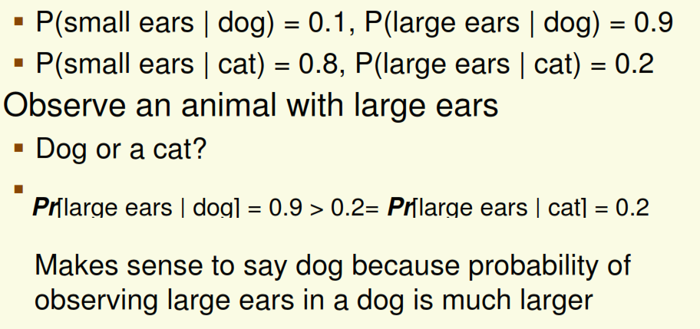

Q: (Math 1.2) fish experts have found that the length of Salmon and Bass fishes follow the Gaussian distribution (i.e., Normal distribution) with mean of 5 and 10 inches, respectively and variance of 1 and 4 inch² , respectively. Now, a fish is observed with length of 7 inch.
- Explain how an MLE classifier would classify it - Salmon or Bass?
- What will be the classification decision by the MAP/Bayes classifier?
- What will be the classification by MLE and Bayes classifier
  - if Salmon and Bass are equally likely
  - if Salmon is twice as likely as Bass?

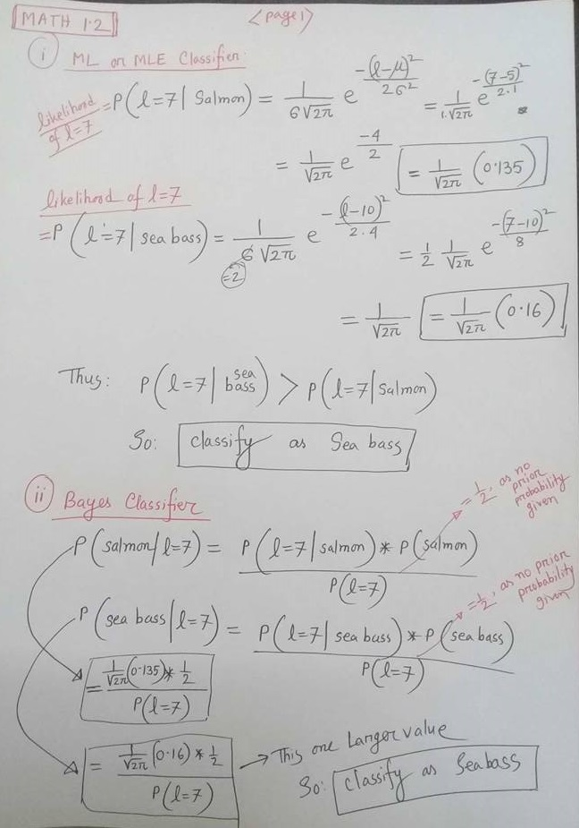
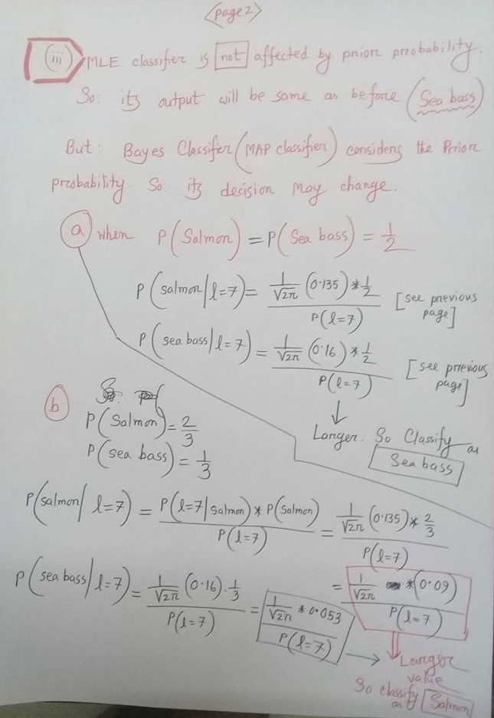
Q. (Math 1.3) fish experts have found that the length of Salmon and Bass fishes follow the Gaussian distribution (i.e., Normal distribution) with mean of 5 and 10 inches, respectively and variance of 1 and 4 inch² , respectively. Find the decision boundary between the Salmon and Bass classes based on their length, when no prior knowledge is available.
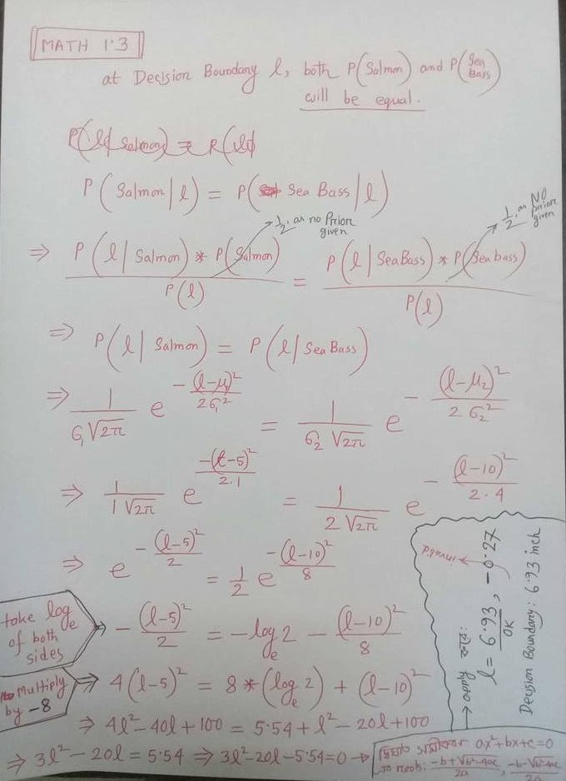
(Math 1.4) Fish experts have found that there are twice as many Salmon as sea bass. With this prior knowledge, How should the MLE classifier and Bayes classifier classify a fish of length 7.0?
Already answered in (Math 1.2) (iii)

Q. (Math 1.5) Find the decision boundary between the Salmon and Bass classes based on their length, for both MLE and Bayes Classifier, when we have the prior knowledge that there are twice as many salmon as there are sea bass.
Answer: The decision of MLE classifier is not affected by the Prior probability, so its decision remains the same as before (6.93 inch, as shown b4 (see previous page), no matter what the probability of Salmon and Sea Bass ).

However, the MAP classifier (Bayes Classifier) considers the Prior probabilities. See Details below (Next Page)

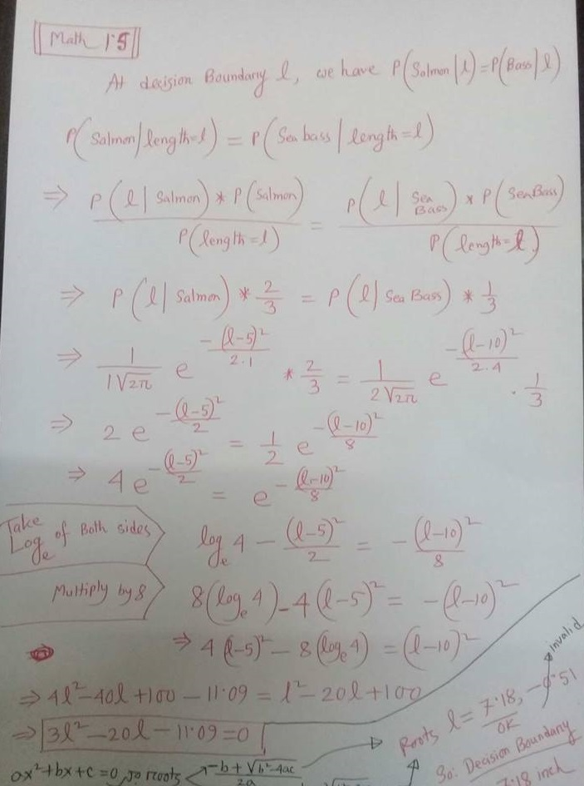
Q. (Math 2.1) Respected fish expert says salmon’s and sea bass’ lengths have Gaussian distributions. Also, the following 12 fish have been observed on a Test day with the accompanying lengths in inch — (salmon, 4), (bass, 8), (bass, 12), (salmon, 5), (salmon, 6), (salmon, 4), (bass, 10), (bass, 12), (salmon, 5), (salmon, 5), (salmon, 4), (salmon,7). Now, a fish is observed with length of 7 inch. What will be the classification decision by the Bayes classifier?

Answer:
Mean of Salmon class = (4+5+6+4+5+5+4+7) / 8 = 40 / 8 = 5.0
Variance of Salmon class
= [(4-5)² + (5-5)²+(6-5)² +(4-5)²+(5-5)² +(5-5)²+(4-5)² +(7-5)²] / (8) = 8 / 8 = 1

Mean of Sea Bass class = (8+12+10+12) / 4 = 42 / 4 = 10.5
Variance of Sea Bass class
= [ (8-10.5)² + (12-10.5)² + (10-10.5)² + (12-10.5)² ] / (4) = 19.0 / 4 = 4.75

Prior Probabilities:
P(Salmon) = 8/12 = 2/3
P (Sea Bass) = 4/12 = 1/3

Now Solve in the Same as answered in (Math 1.2) (iii).b, but use the new values of Mean and Variance and Priors => mean of 5 and 10.5 inches and variance of 1 and 4.75 inch²

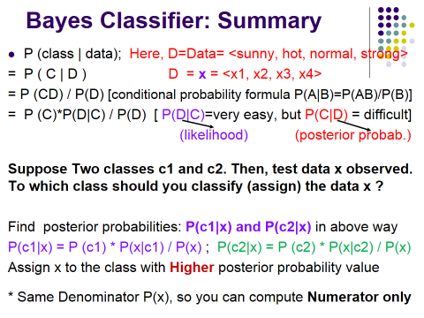
<slide 26>
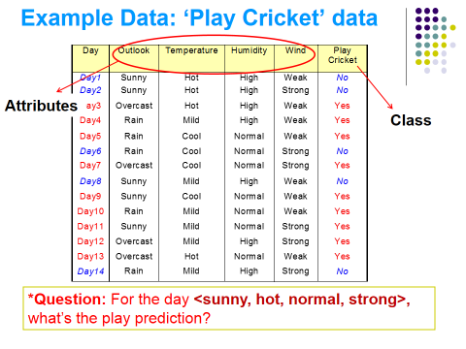
<slide 27>

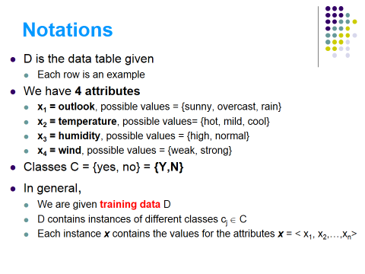
<slide 28>

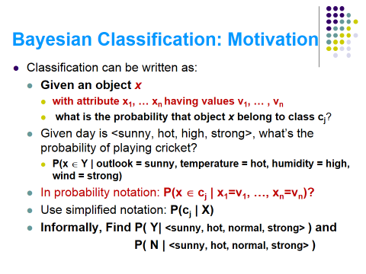
<slide 29>

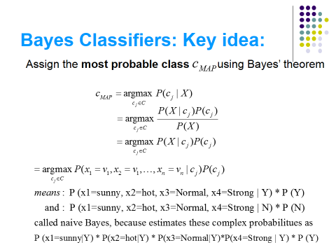
<slide 30>

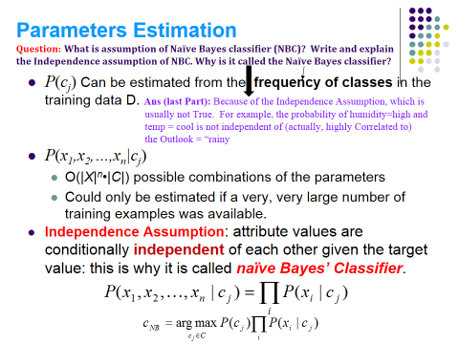
<slide 33>

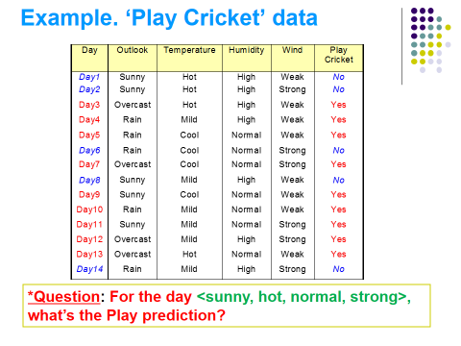
<slide 35>

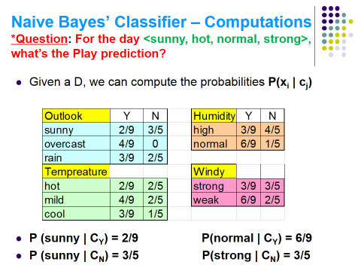
<slide 36>
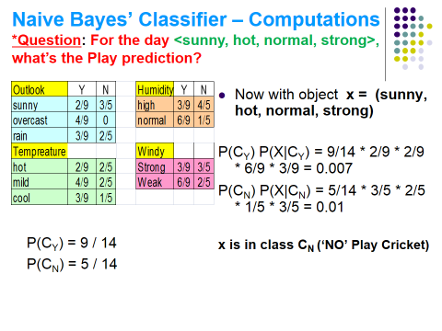
<slide 37>

